Novel Ion trap design for quantum computing applications

sdmay24-38

Client: Durga Paudyal ([durga@ameslab.gov](mailto:durga@ameslab.gov))

Advisors: Jonathan Smith ([jdhsmith@iastate.edu](mailto:jdhsmith@iastate.edu)), Gavin Nop ([gavin.nop@gmail.com](mailto:gavin.nop@gmail.com))

Ezra Manus - Research Lead

Calvin Mitchell - Structural Engineer

Andrew Wilken - Verification Engineer

Robert Laskey - Fabrication Engineer

[sdmay24-38@iastate.edu](mailto:sdmay24-38@iastate.edu)

<https://sdmay24-38.sd.ece.iastate.edu/>

Revised: April 27th, 2024

**Project overview 2**

Introduction 2

Summary of Requirements 3

Development Standards & Practices Used 3

Security Concerns 3

Design Changes from 491 4

**Design and implementation 4**

Design requirements 4

Design and functionality 4

Context on Qubits and Coherence Time 4

Multi-level Ion trap device using a rare-earth qubit 5

Electromagnetic Field Theory 5

**Testing 7**

Variac testing 7

Transformer testing 8

Single-level linear trap testing 8

Dual-level trap testing 9

Testing for trapping: 9

**Broader Context 9**

**Conclusion 9**

**Appendix 10**

Citations 10

# Project overview

## Introduction

Qubits are a necessary component of almost all quantum technologies.

Despite great efforts, not all the properties and behaviors of the presently known qubits are understood. Furthermore, various quantum technologies require novel solutions; thus, new qubit designs should be explored. The coherence of qubits are highly dependent on outside influences, and so solutions to mitigate these effects are necessary. We aim to implement a proof of concept for a novel ion trap design that will mitigate outside influences.

The design of this trap allows for multidimensional movement of multiple particles, which would be used for processes like Quantum Computing, Quantum transduction, and Quantum communication. The novel trap design is an implementation of an existing device called the linear paul trap that allows for more control by utilizing two linear traps to create a stronger trapping region. Other similar implementations require out of phase electrodes, which is extremely challenging to make; this design does not require these which makes the design phase much easier. This device would be used largely by researchers looking to improve quantum computers, as well as hardware and software developers attempting to build large-scale multi-qubit Quantum Computers.

## Summary of Requirements

* Provide proof of concept for a novel ion trap design by inducing movement on particles using RF electrodes
* Understand the properties and behaviors of ion traps
* Explore new ion trap designs for various quantum technology applications
* Understand microscopic effects of RF and DC electrode implementation

## Development Standards & Practices Used

Engineering Standards:

* ISO 9001
* IEEE Standards
* Safety Standards
* Environmental Standards
* Data Security Standards
* Laboratory Standards
* Ethical Standards
* Reporting and Publication Standards

## Security Concerns

Due to the nature of the project, there were a number of safety concerns. First, the transformer went up to voltages of 3.5 KV. Furthermore, one of the particles used was lycopodium, which is highly flammable.

In order to counteract these issues, a number of steps were taken. First, the transformer was isolated and grounded by inch thick styrofoam, as well as any conductors connected to the transformer. A variac was used to gradually lower the voltage, so shut off was not instant. Finally, every configuration was run without any particles, to confirm the safety of the circuit and ensure there was no arcing.

Lycopodium was kept in a fire safe cabinet, and anything contaminated with lycopodium was disposed of separately.

## Design Changes from 491

There were of course changes from the final design presented in 491. The fundamental trap design remained the same, but almost all outside components were changed. It should be noted that the design from 491 did succeed in the final goal of causing oscillations in particles with RF electrodes. After this goal was achieved, we went beyond our goal and set out to actually trap the ion, and this is where changes were implemented. First, The particle used was changed from styrofoam to flour to Lycopodium powder. The method of charging was changed to a teflon rod. Finally, illumination with a laser was implemented to better see particles.

# Design and implementation

## Design requirements

Initially, our design requirements applied to the microscopic concepts of the project, which was the element used as the ion. This was purely a theoretical exercise to help us first understand the complexity of ion traps in a physics and mathematical context, and second, the intricacies of designing an ion trap with an ideal environment and ideal equiptment.

The primary design elements of the final project, which was the large-scale proof of concept, were the electrodes and the particle used. The size and geometry of the electrodes and the electrode placement (primarily spacing and orientation) were of massive importance to our design, as the conditions required top trap the particle yield only a very small actual trapping region. The particle we chose to use was also of utmost importance due to 1) the size of the trapping region, and 2) the charge to mass ratio of the particle, which ultimately dictates if a particle is able to be trapped by the EM fields at all.

## Design and functionality

### Context on Qubits and Coherence Time

* Hyperfine qubits are used for TIQC
  + Hyperfine refers to when a single energy level is split into multiple smaller energy levels
  + Qubit states are defined by the lower energy state (|0>) and the higher energy state(|1>)
  + These qubits are highly susceptible to environmental perturbations and must be adequately isolated
* Coherence time is a term used to express how long a qubit can maintain its state without losing its superposition (collapsing to initial state) due to environmental perturbations
* Extremely accurate lasers are used to perform splitting, state initialization, cooling, and gate operations
* Need: Isolated qubit resistant to environmental effects while able to be manipulated by lasers

### Multi-level Ion trap device using a rare-earth qubit

* Rare-earth qubit (Erbium): Due to the band structure and unique energy band characteristics of Erbium, hyperfine splitting of specific energy levels allows surrounding energy levels to act as natural barriers to environmental perturbations such as changes in EM fields or light contamination
* Implanting the ion within a crystal works but subjects the ion to crystal effects
* Using intentional electric fields and finely tuned lasers, ions can be levitated and moved, allowing for extremely precise operations including cooling, entanglement, and gate operations
* Expand upon the concept of a linear trap to create a dual trap

### Electromagnetic Field Theory

Single level:

* Earnshaw’s theorem states that particles can not be trapped in a static electric field, but oscillating fields are able to bypass this law.
* Connecting one wire of a transformer output to the RF electrodes and the other to ground applies an oscillating voltage to the RF electrodes which causes the oscillating movement of charge carriers along the length of the electrode, creating an electric field surrounding the electrode that is capable of manipulating charged particles assuming the voltage, geometry, and spacing of electrodes is correct.
* Trapping is possible due to the parabolic cone shaped field shown in the figure below. A saddle point is formed at the “tip” of the cone (purple region) that is created by the oscillating electric field. At this point, a particle within the saddle point is rapidly pulled back and forth, fast enough that the movement of the particle is only several nanometers (in a real, microscopic implementation; in our case this distance will be large enough to see with the naked eye) and the particle is effectively trapped in the x direction. The DC electrode controlls y-axis trapping, and “end cap” dc electrodes control z-axis trapping.



Dual level:

* Principles that apply to the single trap can be applied to a dual level trap
* By taking the geometry discussed with the single level trap, flipping it upside down, and then rotating it 90°, a cube-shaped trapping area is formed that ensures the particles are trapped in all directions.

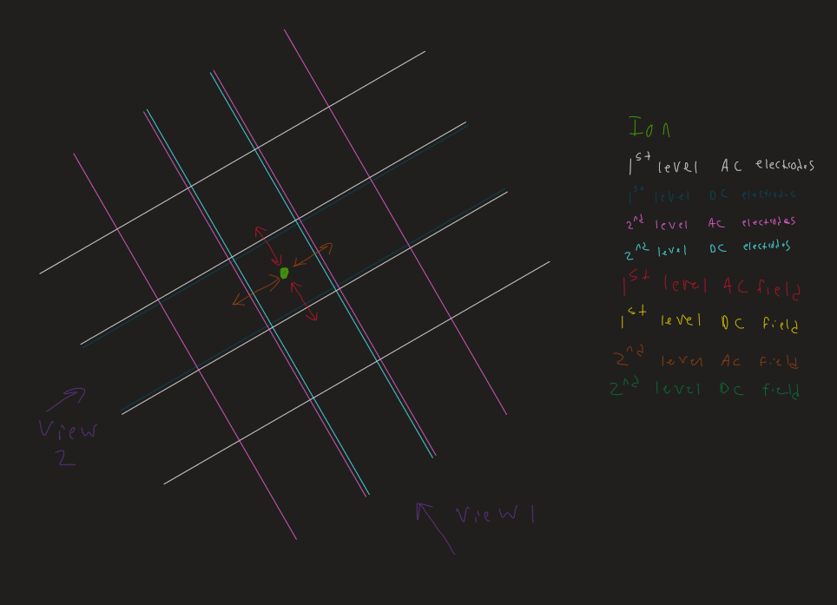

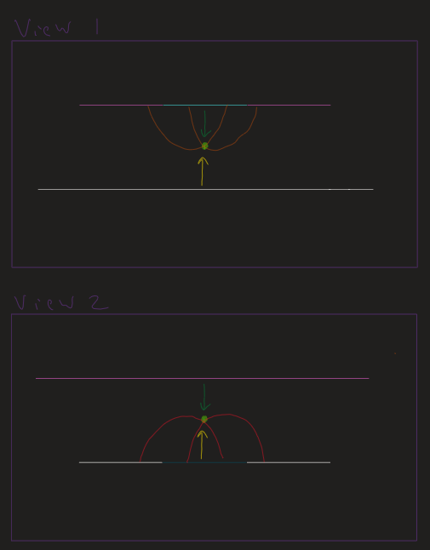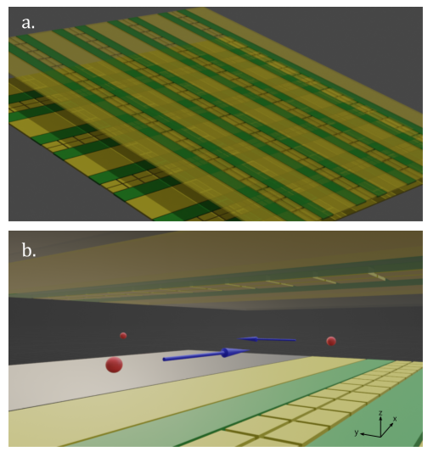

# Testing

Extensive testing was performed over the course of this project. We set up a simple process for testing. We started by testing each of the components used in the design, like the transformer and Variac. We then went on to test the performance of one linear trap, and then our final novel trap was tested last.

## Variac testing

We needed to ensure the variac worked as intended, outputting the AC Voltage and cranking the dial on the variac, observing Vrms every 5 V. This resulted in the graph below.

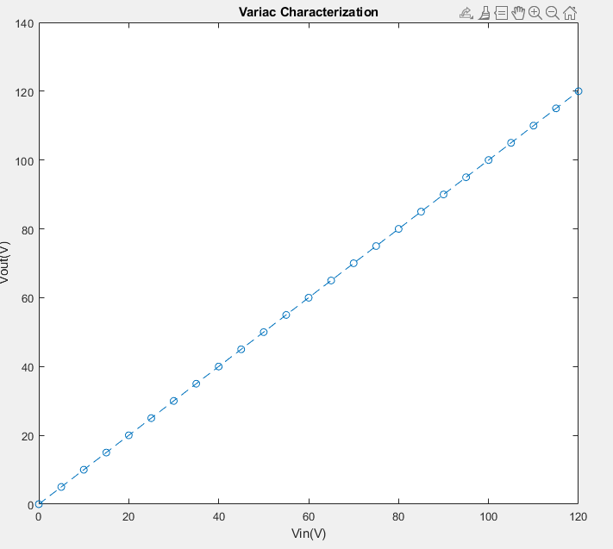

## Transformer testing

We needed to ensure that the transformer worked as intended, and was able to step up the voltage at the frequency Required. To do this, we input a signal at 60hz and stepped up the amplitude by .5V, then calculated the gain. You can see below that with loading the gain was essentially linear.

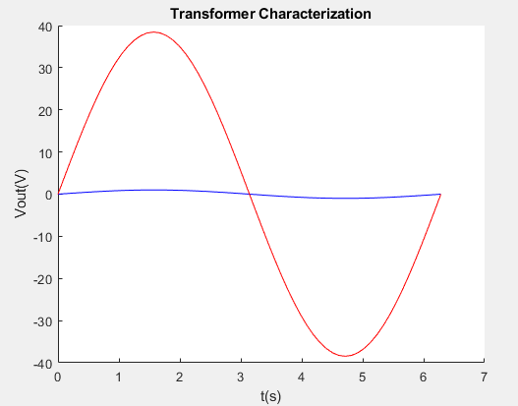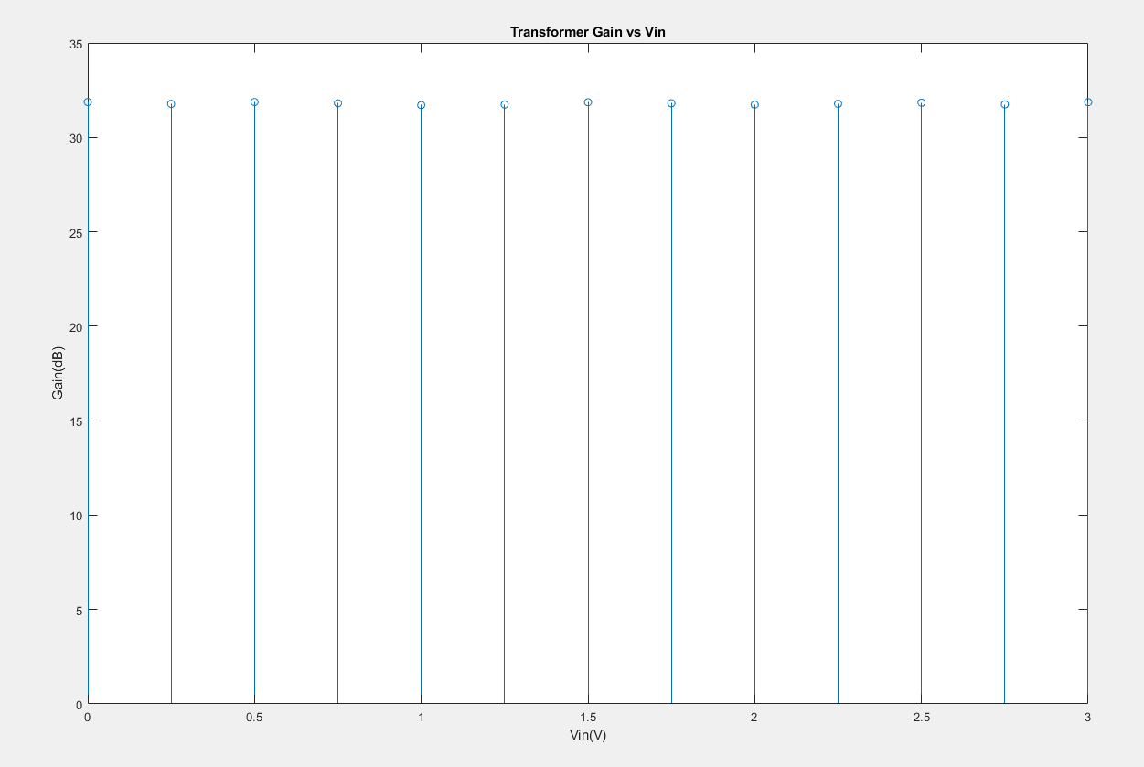

## Single-level linear trap testing

We then moved on to test the linear trap, aiming to generate an electric field capable of causing oscillations in the simulated particle. To do this, we connected the electrode to one end of the transformer, and referenced the other side to ground. Doing this creates the theoretical field we needed. After testing, we were able to to observe movement at about 6hz, which is exactly what we were aiming to see. This movement started at about 2800V, and increased as voltage was increased to the maximum we were able to output at 3500V.

## Dual-level trap testing

We then moved on to test the Dual trap, again aiming to generate an electric field capable of causing oscillations in the simulated particle. To do this, we connected the electrodes to one end of the transformer, and referenced the other side to ground. We did this with 2 of the linear trap configurations. After testing, we were able to observe movement at the same rough frequency of 6hz, which is exactly what we were aiming to see. This movement started at about 2800V, and increased as voltage was increased to the maximum we were able to output at 3500V.

## Testing for trapping:

After we succeeded in the client's goal, we aimed to fully trap the ions. To do this, we tested using the same dual trap design, while changing some of the outside factors.

We first created a housing to help protect the trap from the elements. No differences from prior performance were observed.

We then aimed to change the particle itself. This led to use of laser illumination to properly observe the smaller particles' performance. The results of this change was an ability to see the movement of the particles

We performed the testing with flour. Initially, we were unable to see the particles. After laser illumination, we could see that the particles behave oddly in proximity of the RF electrodes but were not floating.

The next particle used was lycopodium powder. Again, we could see that the particles behave oddly in proximity to the RF electrodes but were not floating.

# Broader Context

Our client is aiming for a patent to be developed from this with our group, along with Gavin and Jonathan. This is where the goal of particle movement came from, to be a proof of concept necessary for a patent. The aim is to send the design we’ve implemented to Sandia Labs to be created at a microscopic level, which could then be used in a quantum computer.

# Conclusion

We succeeded at the main goal of inducing oscillatory movement of particles with our trap. Unfortunately, we were unable to visibly see any lycopodium powder trapped with the use of laser light. However, it is important to note, that if our setup had been performed in a vacuum, eliminating the effects of humidity and air movement, the likelihood of being able to visualize the particle staying suspended between the dual traps is a much higher chance. Aside from that, we would like to highlight that our advisor and clients would like to file a patent for our design prototype capable of inducing oscillating movement.

# Appendix

## Citations

1. Gali, Ádám. "Recent advances in the ab initio theory of solid-state defect qubits" Nanophotonics, vol. 12, no. 3, 2023, pp. 359-397. <https://doi.org/10.1515/nanoph-2022-0723>
2. arXiv:1904.06560 [quant-ph]
3. arXiv:2102.02986 [quant-ph]
4. Lu, Wen-Sen. Josephson circuits for protected quantum bits. Retrieved from <https://doi.org/doi:10.7282/t3-sc2f-xx77>
5. arXiv:2310.07195 [quant-ph]
6. arXiv:2107.05843 [quant-ph]
7. M. K. Singh et al., "Rare earth based solid-state qubit platforms," 2022 International Electron Devices Meeting (IEDM), San Francisco, CA, USA, 2022, pp. 14.2.1-14.2.4, doi: 10.1109/IEDM45625.2022.10019546.
8. AVS Quantum Sci. 3, 044101 (2021); <https://doi.org/10.1116/5.0065951>
9. Yang, L., Wang, S., Shen, M. et al. Controlling single rare earth ion emission in an electro-optical nanocavity. Nat Commun 14, 1718 (2023). <https://doi.org/10.1038/s41467-023-37513-w>
10. Rančić, M., Hedges, M., Ahlefeldt, R. et al. Coherence time of over a second in a telecom-compatible quantum memory storage material. Nature Phys 14, 50–54 (2018). <https://doi.org/10.1038/nphys4254>
11. Siyushev, P., Xia, K., Reuter, R. et al. Coherent properties of single rare-earth spin qubits. Nat Commun 5, 3895 (2014). <https://doi.org/10.1038/ncomms4895>
12. J. C. Bardin, D. H. Slichter and D. J. Reilly, "Microwaves in Quantum Computing," in IEEE Journal of Microwaves, vol. 1, no. 1, pp. 403-427, Jan. 2021, doi: 10.1109/JMW.2020.3034071.
13. Nikolai Lauk et al 2020 Quantum Sci. Technol. 5 020501
14. Bertaina, S., Gambarelli, S., Tkachuk, A. et al. Rare-earth solid-state qubits. Nature Nanotech 2, 39–42 (2007). <https://doi.org/10.1038/nnano.2006.174>
15. arXiv:2103.15743 [quant-ph]
16. arXiv:1802.03354 [quant-ph]
17. Putra, N. K. N. (2021). Design and verification for surface electrode openings of ion trap for
18. scalable quantum computing. Student Research Paper, Nanyang Technological University,
19. Singapore. <https://hdl.handle.net/10356/157994>
20. “3D-Printable Quadrupole Ion Trap | S'Cool LAB.” S'Cool LAB, <https://scoollab.web.cern.ch/3d-printable-quadrupole-ion-trap>. Accessed 3 December 2023.
21. Da An, Clemens Matthiesen, Ahmed Abdelrahman, Maya Berlin-Udi, Dylan Gorman, Sönke Möller, Erik Urban, Hartmut Häffner; Surface trap with dc-tunable ion-electrode distance. Rev. Sci. Instrum. 1 September 2018; 89 (9): 093102. <https://doi.org/10.1063/1.5046527>